**ADAPT™ Framework: A Blueprint for AI Interoperability in Legacy Systems**

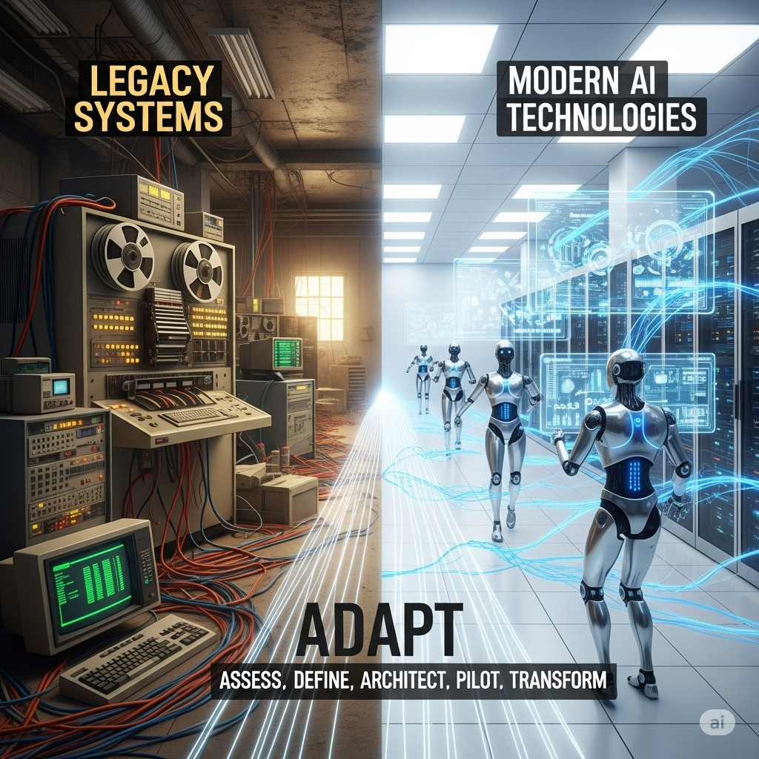

In today's fast-paced digital world, many enterprises are anchored to powerful, mission-critical systems-built decades ago. These legacy systems, while robust and reliable, often exist in a state of digital isolation, disconnected from the modern wave of AI innovation. The challenge is not to discard these valuable assets but to forge a new path for them, where they can seamlessly interact with intelligent agents, large language models, and AI-driven applications.

Forward-thinking product companies are already embracing this transition. For example, Tricentis, a leader in software testing, is implementing MCP-like frameworks to enable AI interoperability for its flagship products like Tosca, qTest, and NeoLoad. By exposing their core functionalities through a standardized protocol, they are opening the curtain for users to co-create features, build custom workflows, and develop by-products around the solutions that Tricentis offers.

Similarly, companies in the financial sector are using similar protocols to allow AI models to access and analyze legacy data for fraud detection and predictive analytics, while manufacturers are modernizing their plant control systems to enable AI-driven optimization and maintenance.

This article provides a detailed blueprint for enabling AI interoperability in legacy systems, outlining a phased, strategic approach using the **ADAPT™.** framework. We will use a more realistic, yet relatable, Windows Desktop Calculator application as our case study to illustrate the journey from a standalone legacy tool to a fully AI-enabled service.

**Assess: The Digital Island**

The journey begins with the current reality of most legacy systems. They are self-contained "digital islands," designed for a different era of computing. User interaction is direct and manual, with functionality confined to the application's native user interface. This is a one-to-one relationship between the end-user and the application's logic.

In our example, the Windows Desktop Calculator is a powerful, multi-featured tool. A user opens the application and manually navigates its various functions—from basic addition to calculating sine or a square root. The application performs its function admirably but has no way to communicate with other systems or receive commands from external sources. It is a powerful, yet siloed, tool.

**Key Challenges:**

* No Automation (in most cases): Operations cannot be automated or scripted by other applications.
* Limited Integration: The system cannot be part of a larger digital workflow.
* No AI Potential: AI models cannot access or leverage the core logic of the system, trapping valuable data and functionality.

**Enabling Technologies for this Phase:**

* **Reverse Engineering Tools:** For deeply complex systems, start with specialized tools. Use **Micro Focus Enterprise Analyzer** or **IBM Application Discovery and Delivery Intelligence (ADDI)** to understand dependencies and data flow in COBOL/mainframe code. For databases, tools like **DB-MAIN** can help generate an Entity-Relationship Diagram (ERD).
* **Project Management & Documentation:** Use **Jira** or **Trello** to organize the audit and prioritization. Store all findings, system diagrams, and feature backlogs in a centralized platform like **Confluence** or **Notion**.

**Define: Breaking Down the Walls with APIs**

The first step in modernization is to create a digital bridge to the outside world. This involves building a thin, modern API layer on top of the legacy system's core functionalities. Instead of a full-scale rewrite, we encapsulate the existing logic and expose it through a standardized protocol like REST.

For our calculator, this would mean developing a lightweight API with separate endpoints for each feature set. For example, a /arithmetic endpoint for addition and subtraction, and a /trigonometric endpoint for sine and cosine. This allows other software applications or services to programmatically access the calculator's specific functions.

**Benefits of this state:**

* Partial Automation: Allows other systems to automate tasks like batch calculations.
* New Integration Opportunities: The calculator's logic can now be integrated into other applications.

**Enabling Technologies for this Phase:**

* **API Design Tools:** Use a design-first approach with tools like **SwaggerHub** or **Stoplight** to define the API's structure using the **OpenAPI Specification (OAS)**.
* **API Development & Testing:** **Postman** and **Insomnia** are invaluable for building, testing, and debugging API endpoints. Use them to rapidly prototype requests and automate testing.
* **Microservices Frameworks:** Develop the API using lightweight frameworks such as **Express.js (Node.js)**, **Django REST Framework (Python)**, or **Spring Boot (Java)** to accelerate development.

**Architect: True AI Interoperability with Layered Architecture**

The final and most transformative phase is the integration of a context-aware protocol through a layered architecture. This is the key to unlocking true AI interoperability. Unlike a simple API, a protocol like the **Model Context Protocol (MCP)** provides a structured, standardized way for AI models to understand the capabilities of an external system and interact with it in a context-aware manner.

This approach uses a centralized MCP Server and two distinct MCP Clients to manage communication securely and efficiently. An External MCP Client serves as the public-facing interface for the AI agent, while an Internal MCP Client resides within the system, translating commands for the legacy application's core logic.

In our example, an AI agent could take a user's natural language request like, "What is the sine of 90 degrees times 10?", and decompose it into a series of steps. The AI would then use the External MCP Client to send this request to the MCP Server, which would invoke the necessary functions on the calculator.

**Enabling Technologies for this Phase:**

* **Integration Platforms:** Use an **Integration Platform as a Service (iPaaS)** like **MuleSoft** or **Boomi** or **Apigee** to manage the communication between the AI client and the legacy system.
* **Containerization & Orchestration:** Use **Docker** to package the MCP server and clients. Use **Kubernetes** to manage and scale these containers in production.
* **Tool-Use Frameworks:** Libraries like **LangChain** and **LlamaIndex** provide pre-built components that handle the complexities of "tool use" for LLMs, enabling them to dynamically discover and use your new system.

**Pilot & Transform: Production Rollout and Scaling**

The final two phases of the A.D.A.P.T. framework are about validating the architecture and scaling the solution across the enterprise. This requires a robust, automated approach to development and deployment.

**Pilot**

* **Task:** Build a simple pilot AI application (e.g., a chatbot) that uses the MCP-enabled system to validate the new architecture and gather early user feedback.
* **Enabling Technologies:** Utilize a **CI/CD pipeline** with tools like **Jenkins**, **GitLab CI/CD**, or **GitHub Actions** to automate the build and deployment process. Incorporate **automated testing** with frameworks like **Pytest** or **Mocha** to ensure quality.

**Transform**

* **Task:** Extend the MCP integration to other legacy systems and new AI models to create a unified, intelligent ecosystem.
* **Enabling Technologies:**
  + **Infrastructure as Code (IaC):** Use tools like **Terraform** or **AWS CloudFormation** to provision and manage cloud resources, ensuring consistent environments and speeding up large-scale deployments.
  + **Monitoring & Observability:** Implement tools like **Prometheus** and **Grafana** to monitor the performance and health of the new services in real time, allowing for quick response to production issues.

**The Future is Not a Single Protocol**

While the Model Context Protocol (MCP) provides a robust and standardized approach, it’s not the only technology evolving in the space of AI interoperability. The field is rapidly maturing with several frameworks and techniques that empower AI models to interact with external tools and data sources. Instead of a single standard, we are seeing a diverse ecosystem of solutions.

* **OpenAI's Function Calling:** A prominent example, this feature allows developers to describe functions to an OpenAI model (like GPT-4) in a simple JSON schema.
* **Agent Frameworks (LangChain, LlamaIndex, etc.):** These open-source toolkits provide components for connecting to various data sources and orchestrating complex workflows.
* **JSON Schema:** At the heart of many of these technologies, including MCP and OpenAI's function calling, is **JSON Schema**. It's a standard format for describing the structure of JSON data, ensuring that the AI model receives and generates predictable, well-formed data.

**Conclusion: A Call to Action for Readers**

The journey from a legacy application to an intelligent, interoperable system is a marathon, not a sprint. The good news is that you don't need to wait for a single, universal standard to emerge. The technologies are already here. By following the **ADAPT™** framework, organizations can systematically transform their legacy assets from isolated relics into powerful, interoperable components of a modern, intelligent enterprise.

* **Educate Yourself:** Start by exploring the frameworks mentioned above.
* **Pilot a Project:** Don't try to modernize your entire system at once. Pick a small, well-defined function in your legacy application, create a simple API for it, and then experiment with connecting it to an AI model using one of the available frameworks.
* **Advocate for Interoperability:** Whether you're a developer, a product manager, or an executive, champion the idea of open, standardized APIs and tool definitions within your organization. The future of enterprise technology is not about building the next closed ecosystem, but about building intelligent components that can work together.